 | Filing Reference : |  | GG/COMS/TS.2/9
 | Document Title : |  | Use-Case Realization Report (Analysis)  Manage Role Approval
 | Version : |  | 1.0
 | Prepared By : |  | Alvin Chang
 | Date Created : |  | Monday, Jul 30th, 2011
Approved By :
 |  | Tran Ba Tien |  | Date
 |  | Project Manager |  | 30th Jul 2011

©2011 [Hoang Kim joint stock Company].
The information contained in this document is the property of [Hoang Kim joint stock Company]. The contents must not be reproduced, wholly or in part, for purposes other than for which it has been supplied, without the prior permission of [Hoang Kim joint stock Company], or, if it has been furnished under contract to another party, as expressly authorised under that contract. [Hoang Kim joint stock Company] shall not be liable for any errors or omissions.

Revision History

Date | Version | Description | Author
30/JUL/2011 | 1.0 | First version | Alvin Chang

Table of Contents
1. Brief Description 4
2. Flow of Events 4
3. Interaction Diagrams 4
3.1 Approve Role Change 5
4. Participating Objects 5
5. Class Diagrams 6
5.1 Approval Role Change 6

Use-Case Realization Report
Manage Role Approval

Brief Description
This use case enables a director to approve a role change (assignment) by a department manager. (Refer to use case Manage Employee-Role).

Flow of Events
The standard flow of events for this use case and any exceptions are described in the following subsections. See section 3 for an overview of the participating Actors and Domain Objects.

Approve Role Change
This use case is for the Director to approve the role changes assigned by the operations manager.

Preconditions
1. To commence using the system, user is required to log in successfully. Refer to Log In Use Case for detail.

Standard Flow
- Director will initiateApprovalOfRoles() on the MainPage.
- This will trigger a showRoleApprovalPage() to the MainController, which will subsequently show() the RoleApprovalPage.
- RoleApprovalPage will getListOfUnapprovedRoles() from MainController, which will call getListOfUnapprovedRoles() from the RoleController, which in turn calls isApproved() in Role object.
- MainController will then refreshRoleList() in RoleApprovalPage.
- Director will then approveSelectedRoles() in RoleApprovalPage which will approveRoles() in MainController, which in turn calls approveRoles() in RoleController, and subsequently calls approveRole() in Role.
- MainController will then refreshRoleList() in RoleApprovalPage.
- This marks the end of this use case.

Exception
- If list of unapproved roles cannot be retrieved, an error message will be shown to user
- If error in updating the approval of roles, an error message will be shown to the user.

Interaction Diagrams

Approve Role Change
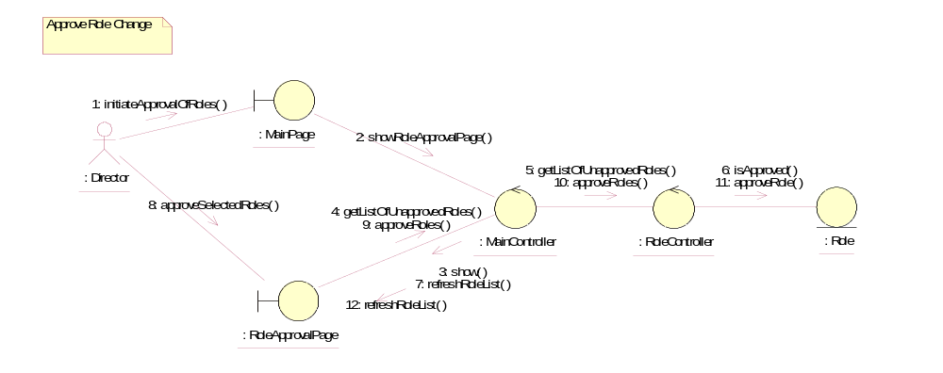

Participating Objects
: Director
This actor represents a director in Golden Gravure.

: Role
This object contains information about the roles.

: RoleApprovalPage
This page represents the UI where the Director will approve / reject the roles assigned to or removed from an employee.

: RoleController
This object controls the operations of the Role object.

: MainPage
This page represents the UI where the user of the system will first enter, and act as a launchpad for the other various pages within the system.

MainController
This object acts as the middleman between the boundary objects and other controllers

Class Diagrams

Approval Role Change
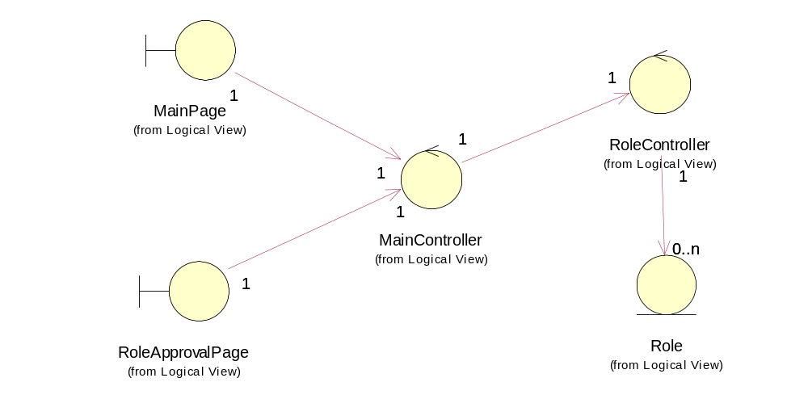

Derived Requirements
None

